ESLint Assignment-1

1. Configure ESLint to your project

App.js

var foo = bar;

.eslintrc

{

"extends": "eslint:recommended"

}

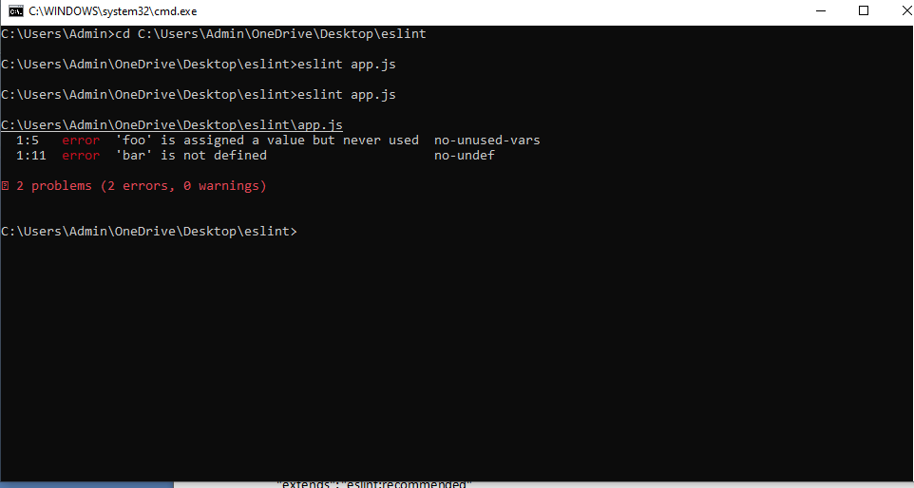

Corrections:

App.js

var bar= 10;

var foo = bar + 20;

document.write(foo);

.eslintrc

{

"extends": "eslint:recommended",

"parserOptions": {

"ecmaVersion": 6

},

"env":{

"node": true,

"browser":true,

"es6":true

}

}

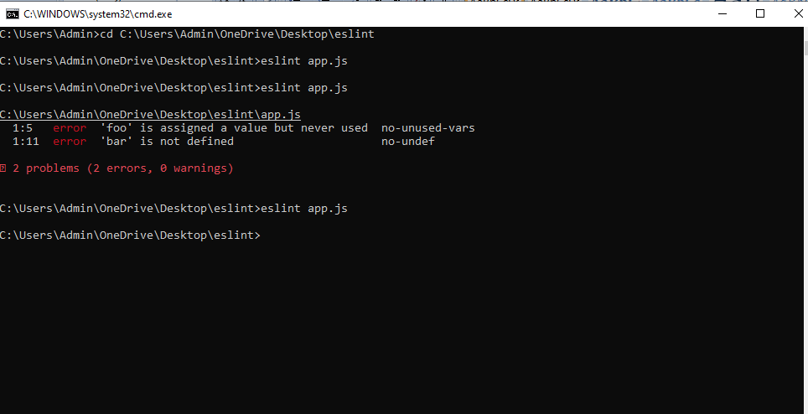

No errors

1. Create a tailoring eslint to write shareable eslint plugin and configurations

Index.js

module.exports = {

globals: {

MyGlobal: true

},

rules: {

semi: [2, "always"]

}

};

Package.json

{

"name": "eslint3",

"version": "1.0.0",

"description": "",

"main": "index.js",

"scripts": {

"test": "echo \"Error: no test specified\" && exit 1"

},

"peerDependencies": {

"eslint": ">= 3"

},

"author": "",

"license": "ISC"

}

